Day4 Outputs:

Doctor_Ques

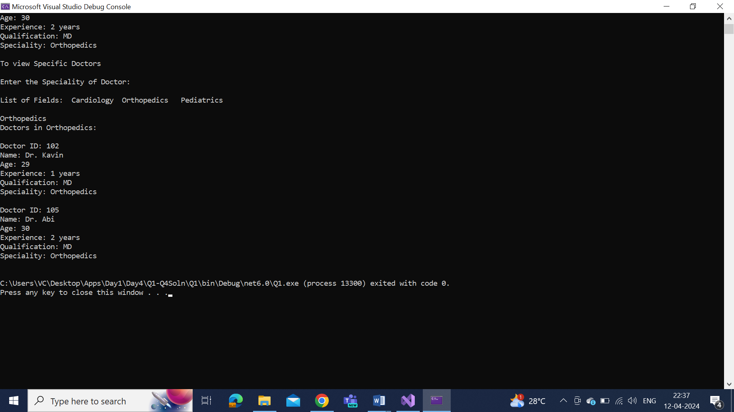

Card_num_Validation

